// Selmi N S

**SHELL SCRIPTING**

DAY 1

IF ELSE

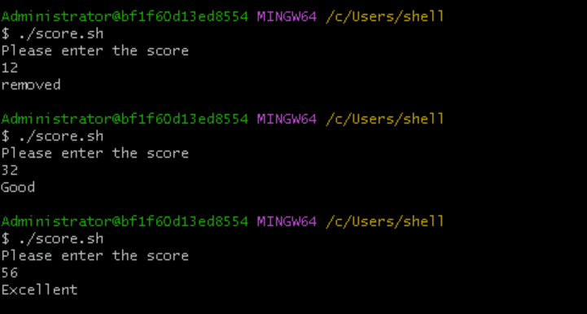

FOR LOOP

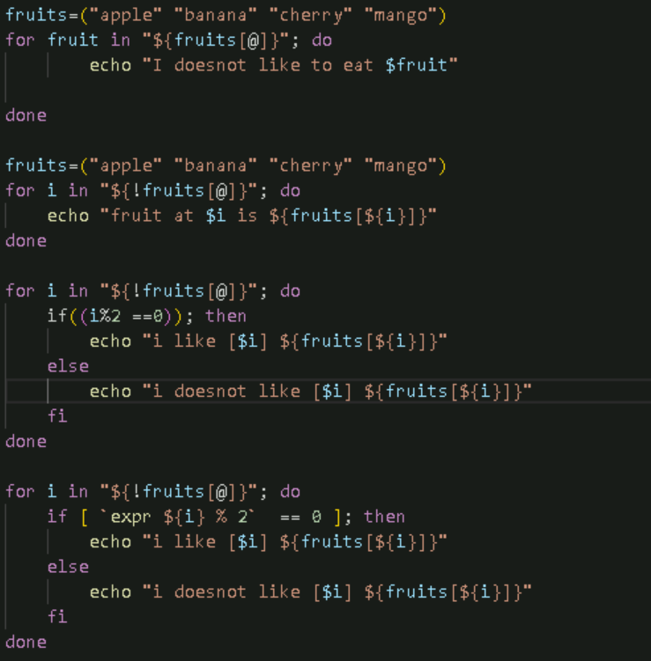

WHILE LOOP

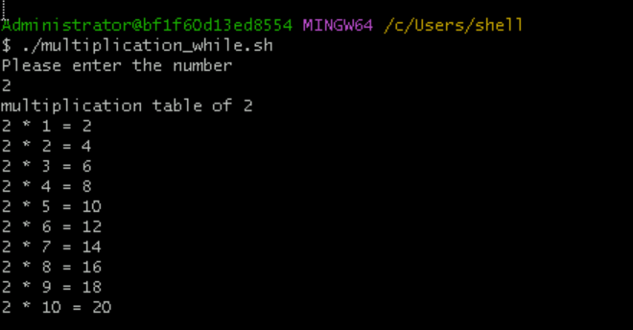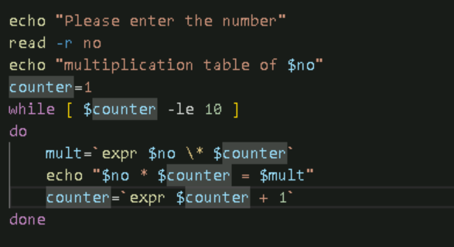

Print the numbers



